**Company Name: ENERGIZE TECHNOLOGIES INDIA PRIVATE LIMITED**

**Work Name: FLYWHEEL BASED GENERATOR**

**Lab Name : IoT Lab**

**Technical Details:**

IoT Sensor Integration: Installation of Sensors (Vibration, Current, Temperature, IR etc) onto equipment contained in system to enable Predictive Maintenance, Continuous System Performance Monitoring and Energy Monitoring Remotely.

**Outcome:**

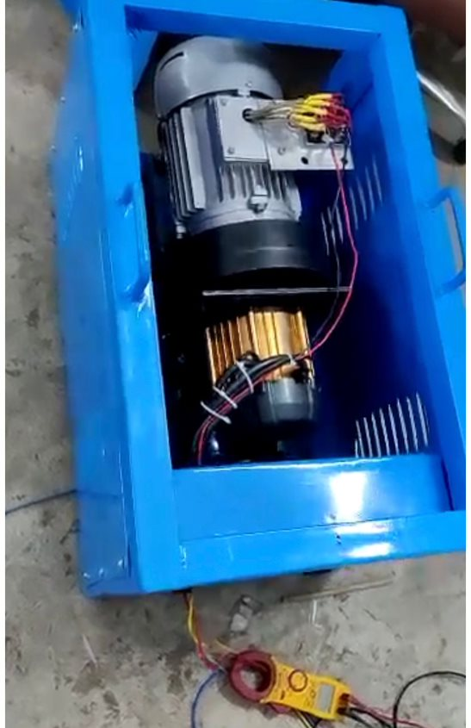

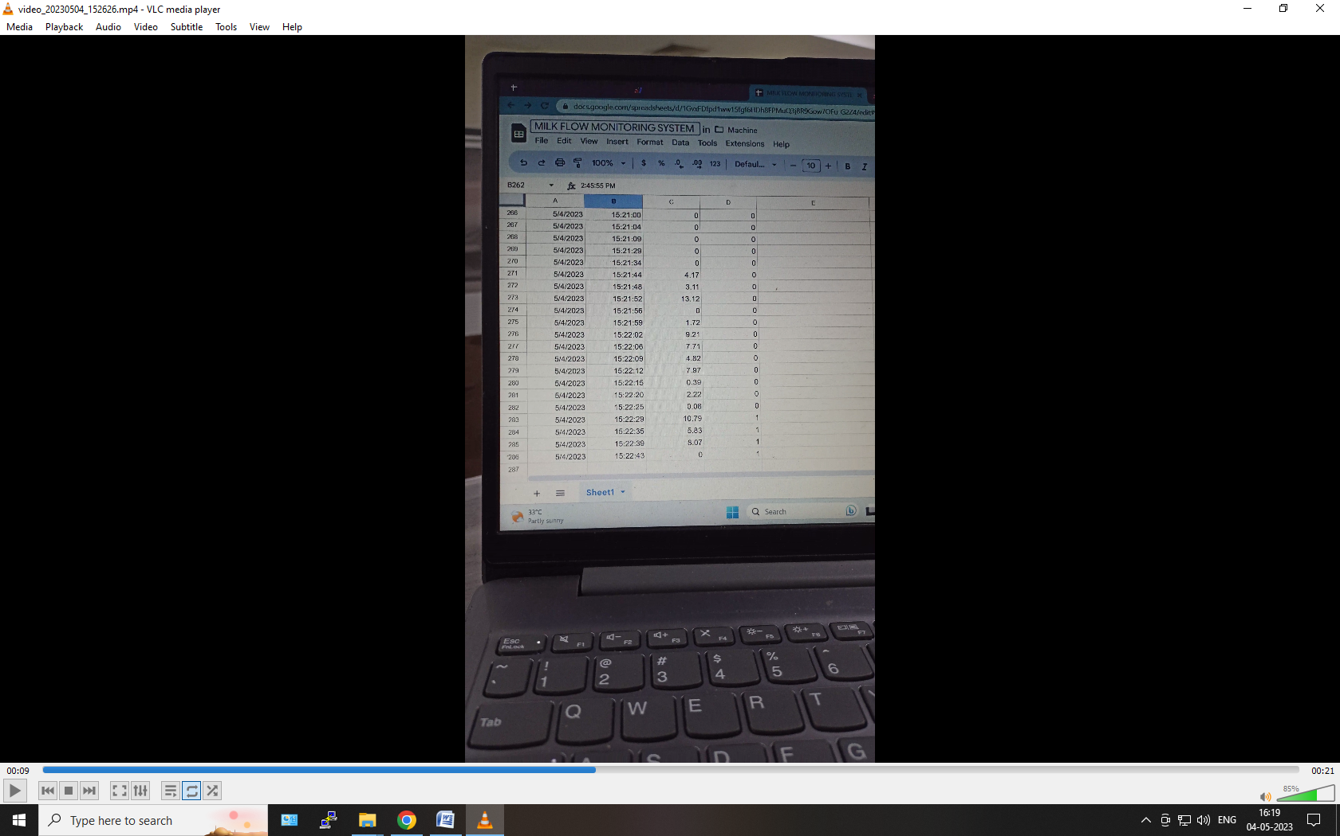

**Introduction:**

The integration of Internet of Things (IoT) sensors onto equipment in a system has revolutionized the way predictive maintenance, continuous system performance monitoring, and energy monitoring are conducted. The installation of various sensors, including vibration, current, temperature, IR, and others, enables remote monitoring and real-time data collection, leading to improved efficiency, safety, and cost savings. This report highlights the benefits and applications of IoT sensor integration and the steps involved in its implementation.

**Benefits of IoT Sensor Integration:**

IoT sensor integration offers several benefits, including:

Predictive maintenance: IoT sensors enable real-time data collection and analysis, allowing for predictive maintenance that can prevent equipment failure, minimize downtime, and extend equipment lifespan.

Continuous system performance monitoring: With IoT sensors, system performance can be monitored remotely, enabling the detection of issues that can affect system efficiency, safety, and reliability.

Energy monitoring: IoT sensors can be used to monitor energy consumption, identify energy inefficiencies, and optimize energy use, resulting in cost savings and reduced environmental impact.

**Applications of IoT Sensor Integration:**

IoT sensor integration can be applied in various industries, including:

Manufacturing: IoT sensors can be integrated onto manufacturing equipment to enable predictive maintenance, optimize performance, and reduce downtime.

Healthcare: IoT sensors can be used in medical equipment to monitor vital signs, track medication compliance, and provide remote patient monitoring.

Energy: IoT sensors can be used to monitor energy consumption in buildings and optimize energy use, resulting in cost savings and reduced environmental impact.

**Steps Involved in IoT Sensor Integration:**

The implementation of IoT sensor integration involves the following steps:

Sensor selection: Determine the type of sensors required based on the equipment and system to be monitored.

Sensor installation: Install the sensors onto the equipment and ensure that they are properly configured.

Data collection: Collect data from the sensors in real-time and store it in a database or cloud platform.

Data analysis: Analyze the collected data using data analytics tools and algorithms to identify trends, patterns, and anomalies.

Visualization: Visualize the data in a user-friendly dashboard or interface that provides real-time insights and alerts.

**Conclusion:**

IoT sensor integration is a game-changer for predictive maintenance, continuous system performance monitoring, and energy monitoring. By installing various sensors onto equipment in a system, real-time data collection and analysis can be conducted remotely, leading to improved efficiency, safety, and cost savings. As the technology continues to evolve, IoT sensor integration is expected to become even more ubiquitous, providing unprecedented insights into system performance and leading to even greater advancements in industry and society as a whole.